Lab 5

Task 1: [Link](https://mercury.swin.edu.au/cos10026/s103809048/lab05/lab05task1.html)

Step 1:

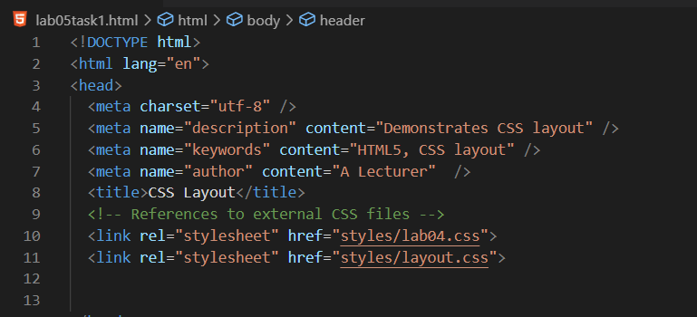

Step 2:

Step 3:

2.

3.

4.

Step 4:

2.

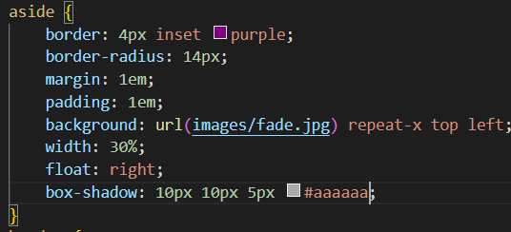

3.

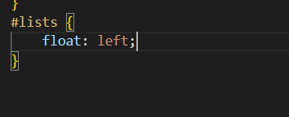

4.

5.

6,7.

8.

9.

10.

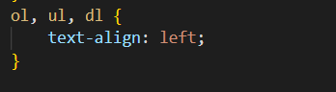

11.

Step 5:

1. .

1. .

1. .

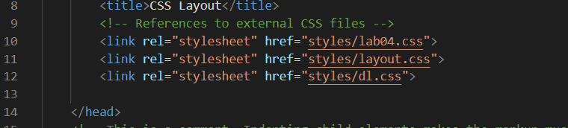

<https://mercury.swin.edu.au/cos10026/s103809048/lab05/lab05task1.html>